**Data Analytics Immersion**

**2.7: Spatial Analysis**

1. Create map of Influenza death of 65+ age in US over year (2009-2017), using state as spatial boundary.

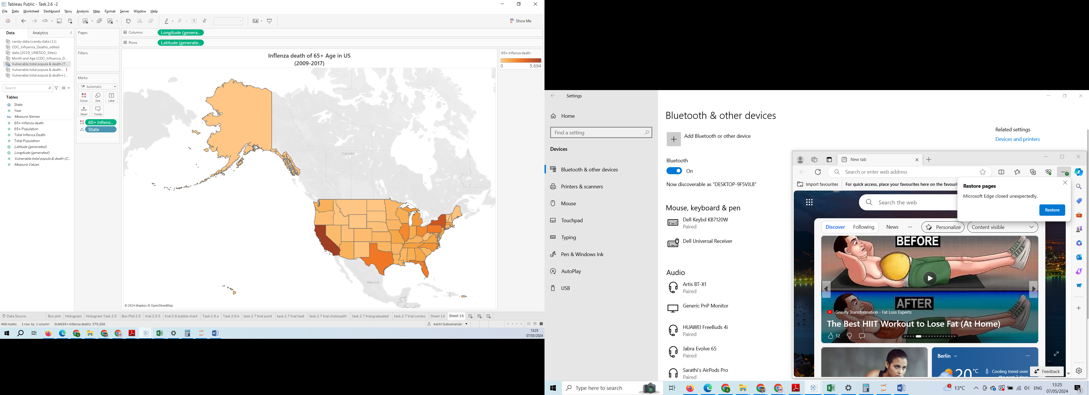

<https://public.tableau.com/app/profile/aarthi.subramanian/viz/Task2_71_17150814432180/Sheet15?publish=yes>

2. Merging Influenza death over population in dual axis

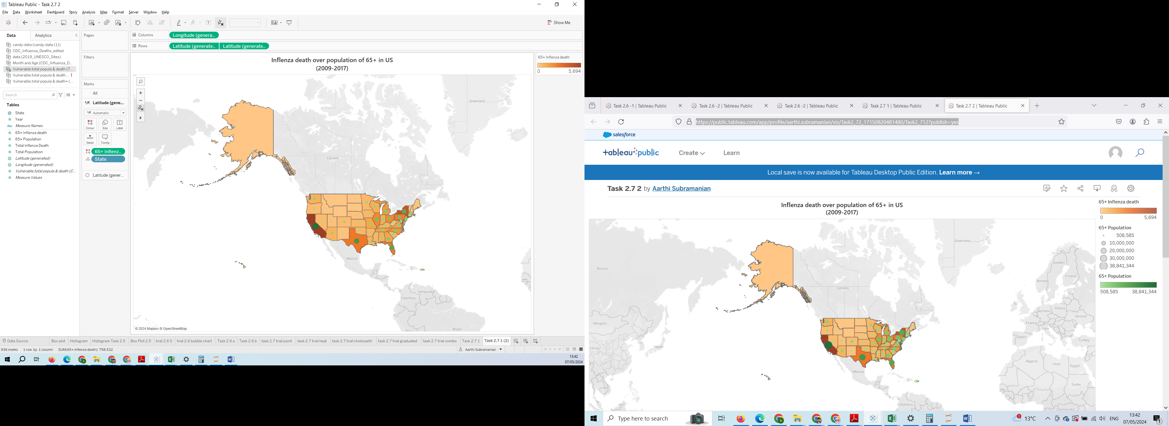

<https://public.tableau.com/app/profile/aarthi.subramanian/viz/Task2_72_17150820481480/Task2_712?publish=yes>

3.

|  |  |  |
| --- | --- | --- |
|  | **Checklist** | Answers |
| Text | 1) Are the title and text descriptive enough? (i.e., do you understand what the visualization is trying to convey just by looking at the title and text?) | Yes |
| 2) Are there text labels? | No |
| 3) Does the text portray any redundant information that could be gotten rid of? | Yes |
| 4) Do colors, shapes, and size scales come with legends? | Yes |
| Color | 1) What does the color scheme signify? | 65+ Influenza Population in USA |
| 2) Are there more than five colors? | No |
| 3) Does the color scheme make sense? Are colors analogous, complementary, monochromatic, or intuitive? | Yes |
| 4) If color is used to draw attention to important information, is the darkest color representing the most important information? | Yes darkest colour having highest count and light color having lowest count |
| Other | 1) Are different sizes used? If so, is there meaning behind the sizes? | This representing death |
| 2) Are there groupings in the data that can be portrayed through color, size, or position? | Yes |
| 3) Is there (enough) whitespace? | Yes |
| 4) Is the visualization accessible? | Yes |
| 5) Can the current chart can be split or merged to make clear? | Yes this is combined map |

4.

a. What states or regions are the highest? The lowest?

|  |  |  |
| --- | --- | --- |
|  | **Lowest Region** | **Highest Region** |
| **Population** | Vermont | California |
| **Death** | Alaska , North Dakota , Wyoming, District of Columbia , Delaware , Vermont , Puerto Rico | California |

California State is highest in both population and death

Vermont State is lowest in both population and death

b. How does time impacts those trends?

Each year the population has increased however mortality has remain balanced.

5. I have added a custom shape in the shape of a person. The different sizes are dependent from the death in region. And added annotations

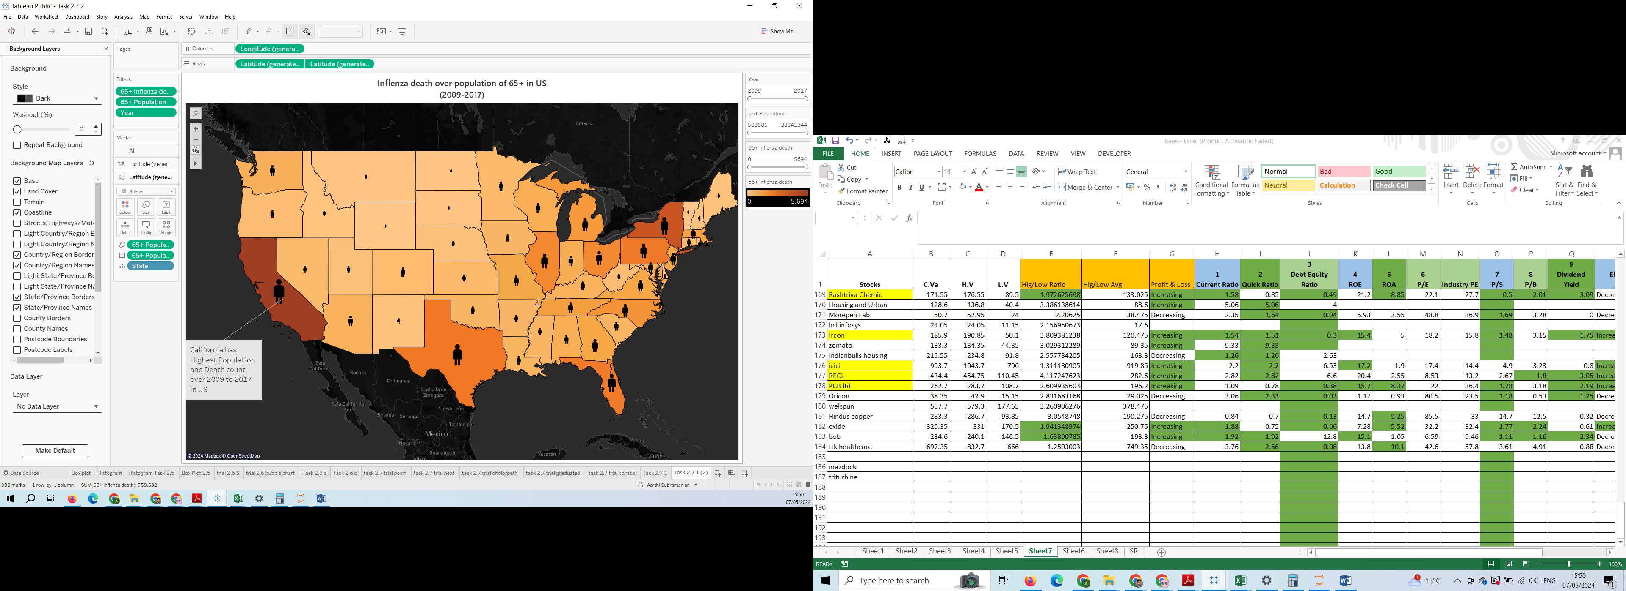

<https://public.tableau.com/app/profile/aarthi.subramanian/viz/Task2_73_17150900348920/Task2_712?publish=yes>

**Resources:**

Clear Error for State not Recognised in Tableau: <https://www.youtube.com/watch?v=RDsg75H_J6k>

How to add custom shapes and icons in Tableau dashboards: <https://www.youtube.com/watch?v=Q6yP5pppOsQ>